**ASSIGNMENT:1**

**Section 1: Multiple Choice**

**1. Which of the following is NOT a component of the CPU?**

**🡪**RAM

**2. What is the function of RAM in a computer?**

**🡪** A computer's RAM stores data for short-term use

**🡪**It reads files faster

**🡪**improve application performance

**3. Which of the following is a primary storage device?**

**🡪** HDD & SSD

**4. What is the purpose of a GPU?**

**🡪**The main purpose of GPU is to perform work related to graphical representation such as playing videos & showing effects to display. It is also useful for learning AI, crypto mining & machine learning.

**Section 2: T or F**

**5. True or False: The motherboard is the main circuit board of a computer where other components are attached.**

**🡪**True

**6. True or False: A UPS (Uninterruptible Power Supply) is a hardware device that provides emergency power to a load when the input power source fails.**

**🡪**True

**7.** **True or False: An expansion card is a circuit board that enhances the functionality of a component.**

**🡪**True

**Section 3: Short Answers**

**8. Explain the difference between HDD and SSD.**

**🡪 HDD:**

* HDD is slower than SSD
* HDD has a larger capacity
* It stores data in a magnetic disk
* The cost of HDD is cheaper

**SSD:**

* SSD is faster than HDD
* It has a low capacity
* SSD stores data in a Flash memory
* The cost of SSD is expensive

**9. Describe the function of BIOS in a computer system.**

**🡪**The BIOS (Basic Input/Output System) is software that is embedded on a motherboard that provides the functions for booting a computer and managing hardware components.

**Key functions:**

* Power-on Self-Test
* Hardware Initialization and Configuration
* Booting the System
* Basic Hardware Control

**10. List and briefly explain three input devices commonly used with computers.**

**🡪** **Input devices :**

* Keyboard
* Mouse
* Scanner
* Webcam
* Joystick

1. **Keyboard:**

It is a device that inputs text and commands by pressing keys. It consists of letters, numbers, and special function keys.

1. **Mouse:**

It is a pointing device that controls the cursor on the screen by moving it across a surface. It includes buttons for clicking and a scroll wheel.

1. **Scanner:**

A scanner is an optical device that converts physical documents, photos, or objects into digital formats that can be stored or edited on a computer.

Section 4: **Practical** Application

**11. Identify and label the following components on a diagram of a motherboard: ●CPU ● RAM slots ● SATA connectors ● PCI-E slot**

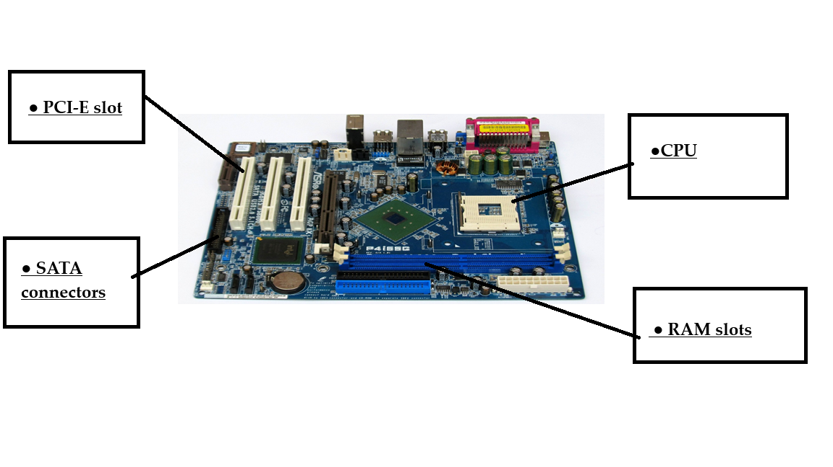

**12. Demonstrate how to install a RAM module into a computer.**

-install RAM module into a computer:

**1) Prepare workspace:**

-Turn off the computer and unplug all cables.

-Place the computer on a flat surface with easy access to the case.

-Remove metal objects to avoid static electricity damage.

**2) open the computer case:**

-Locate the screws holding the side panel of the computer case and remove them using a suitable screwdriver.

-Gently lift the side panel to access the internal components.

**3) locate the RAM slots:**

-Identify the RAM slots on the motherboard, usually near the CPU.

-These slots will have small clips on either side that hold the RAM modules in place.

4**) Remove existing RAM:**

-If you need to replace existing RAM, gently press down on the clips at each end of the RAM module to release it.

-Carefully pull the RAM module straight up out of the slot.

**5) Align the new RAM module:**

-Inspect the new RAM module for a small notch on one side.

-Locate the corresponding ridge in the RAM slot on the motherboard and align the notch with it.

**6) Install the RAM module:**

-Hold the RAM module at a slight angle with the notch aligned.

-Firmly press the RAM module into the slot until you hear a click, ensuring the clips on the sides snap into place.

**7) Close the computer case and power on:**

-securely reattach the computer case side panel and screw it back in.

-Plug the computer back in and power it on.

-Check BIOS settings to verify that the new RAM is recognized correctly.

**Section 5: Essay**

**13. Discuss the importance of proper cooling mechanisms in a computer system. Include examples of cooling methods and their effectiveness.**

- A proper cooling mechanism in a computer system is crucial to maintain optimal performance, prevent hardware damage, and extend the lifespan of components by regulating heat generated during operation; without adequate cooling, components like the CPU and GPU can overheat, leading to performance throttling, instability, and potential failure, making a well-designed cooling system essential for reliable computing, especially in high-performance systems like gaming PCs or servers.

**- Key points about proper cooling in computer systems:**

**1)Heat Dissipation:**

The primary function of a cooling system is to remove excess heat generated by the computer’s components, ensuring they operate within their safe temperature range.

**2)Performance Impact:**

Overheating can accelerate wear and tear on components, ensuring in noticeable slowdowns during demanding tasks.

**3)Component Longevity:**

Excessive heat can accelerated wear and tear on components, potentially leading to premature failure.

**- Example of cooling methods and their effectiveness:**

**1)Air cooling:**

-Passive: Utilizes heat sinks with large surface area to radiate heat naturally, suitable for low power components.

-Active: Combines a heat sink with fans to actively circulate air, providing better colling for higher-power components, commonly found in most desktop PCs.

-Effectiveness: Generally cost-effective and simple to implement, but may not be sufficient for high-performance systems under heavy loads.

**2)Liquid cooling:**

-Liquid-to-air cooling: A circulating liquid absorbs heat from the components, then transfers it to a radiator where fans cool it down.

-Immersion cooling: The entire system is submerged in a dielectric liquid, offering excellent heat dissipation but requires specialized equipment.

-Effectiveness: Generally cost-effective and simple to implement, but may not be sufficient for high-performance systems under heavy loads.

**3)Heat pipes:**

-Utilizes a sealed tube filled with a working fluid to transfer heat efficiently from a hot source to a cooler area.

-Effectiveness: Often used in conjunction with other cooling methods to enhance heat transfer from specific areas.

**14. Explain the concept of bus width and its significance in computer architecture.**

Bus width refers to the number of bits that can be transmitted simultaneously over a computer's bus. The bus is a communication system that transfers data between various components of a computer, such as the processor, memory, and input/output devices. The bus width determines how much data can be transferred at once, affecting the overall system performance.

**- Key Concepts:**

**1. Data Bus:** This is the part of the bus that carries data between the CPU and memory or between other components. The width of the data bus determines how many bits of data can be transferred simultaneously.

**2. Address Bus:** This part carries the address information to specify where the data should be read from or written to in memory. The width of the address bus influences how much memory can be addressed by the system.

**3. Control Bus:** This carries control signals for synchronization and regulation of data flow. It doesn't typically affect the width directly, but it is essential for coordinating the transfer of data.

**- Significance of Bus Width:**

**1. Data Transfer Speed:** A wider bus allows more data to be transferred in a single clock cycle. For example, a 64-bit bus can transfer twice as much data as a 32-bit bus in the same amount of time. This leads to higher data throughput and faster system performance.

**2. System Performance**: The bus width directly impacts the performance of the system. For example, a system with a 64-bit bus can execute more operations per second compared to one with a 32-bit bus, given all other factors are the same.

**3.** **Memory Addressing:** The width of the address bus determines how much memory the system can address. For example, a 32-bit address, which is 4 GB of addressable space. A 64-bit address bus , allowing for much larger memory sizes.

**4. Compatibility and Extensibility**: Wider buses enable support for newer, more advanced applications that require more memory or higher data transfer rates. As software becomes more demanding, a wider bus helps ensure that the system can handle the increased requirements.